Info. Sheet for 2026 Autumn Exchange Students

- General information
Name of Institution | Korea University of Technology and Education (KOREATECH)
Website | https://www.koreatech.ac.kr/eng
Address | Korea University of Technology and Education  1600 Chungjeol-ro, Byeongcheon-myeon, Dongnam-gu,  Cheonan, Chungcheongnam-do,  Republic of Korea  Postal code: 31253
Dean of External Affairs | Nam Min Cho (Prof.)  Phone: +82-41-560-2501  Email: nmcho93@koreatech.ac.kr | English/Korean speaker
Director of External Affairs | Eun Young Park (Ms.)  Phone: +82-41-560-1206  Email: eypak@koreatech.ac.kr | English/Korean speaker
Inbound programs officer/ Outbound programs officer | WOOCHAN KIM (Mr.)  Phone: +82-41-560-1795  Email: hahas507@koreatech.ac.kr | English/Korean speaker
Inbound programs officer/ Outbound programs officer | Xuejun Zhang(Mr.)  Phone: +82-41-560-2502  Email: zxj100@koreatech.ac.kr | Chinese/Korean speaker
Foreign students service manager | WOOCHAN KIM (Mr.)  Phone: +82-41-560-1795  Email: hahas507@koreatech.ac.kr | English/Korean speaker
Foreign students service manager | Xuejun Zhang(Mr.)  Phone: +82-41-560-2502  Email: zxj100@koreatech.ac.kr | Chinese/Korean speaker

- Application deadline
Nomination Deadlines | Nomination deadlines  May.27 th 23:59(KST) for 2026 Autumn semester
Application Deadlines | Application deadlines  May.29 th 23:59(KST) for 2026 Autumn semester

- Requirements and application
Requirements | - Undergraduate Students Only  (must have completed at least 2 semesters at home university)  - Students have enough English or Korean proficiency to understand lectures
Tuition Fee | All incoming exchange students coming from partner universities are exempt from paying tuition fees at KOREATECH
Nomination procedure | Nominations must be submitted by the home university coordinator.  (Partner universities will receive a Google Form link for nomination. The application form and instructions will then be sent directly to each nominated student’s email address.)
Application procedure | Incoming students must send the application and required documents by electronic mail to hahas507@koreatech.ac.kr within the deadline (see above)
Application documents | - Application form  - Official certificate of registration of current institution  - Official transcript from current university (every semester)  - Copy of passport  - (Optional) TOPIK or English language certificate within 2 years  - Personal Medical(travel) Insurance  (Must be submitted upon arrival at KOREATECH)
Health Insurance | - All international students are automatically enrolled in the Korean  National Health Insurance (KNHI) after receiving their Alien Registration Card (approx. 1–1.5 months after arrival).  - The insurance covers most medical expenses, significantly reducing  hospital fees compared to the original cost.  - The monthly premium is about 79,000 KRW, and the first payment  usually covers two months(September to October).  - Since there is a gap before KNHI becomes active, students must  purchase private insurance covering at least the first two months after arrival.  - Non-payment of KNHI premiums may cause issues (e.g., visa extension).  - French students may apply for exemption under bilateral agreements;  students from other countries are not eligible.
VISA requirement | Students must have a valid VISA. In order to apply for it, they may ask for an official invitation letter and Certificate of Admission (we will issue an invitation letter and certificate for each student) to submit along with the other documents to the Korean embassy.

- Available departments and English courses
Available departments | - Mechanical engineering  - Mechatronics Engineering  - Electrical and Electronic Engineering  - Computer Science and Engineering  - Industrial Management
English Courses | - English courses for the Autumn semester 2026 are not yet determined.  - A new announcement will be made once they are confirmed.  ※ Course registration is available within the subjects offered by the eligible departments.
- Grading system
KOREATECH evaluates students’ performance comprehensively with mid and final test scores, homework scores, and attitude. We use 4.5 Scale GPA, See Appendix A. for details

- Academic Calendar
- Academic calendar in detail will be offered after application.
2026 Autumn | - Aug 31st: Autumn semester starts  - Sep 2nd ~ 4th: Course add/drop/change period  - Dec 14th ~ 18th: Final exam week  - Dec 19th ~ 20th: Dormitory moving out days
※ The above schedule may be changed depending on the circumstances.

- Practical Information for Incoming students
Housing | All exchange students will stay at the Chambit (on-campus dormitory). Accommodation is the twin room shared by 2 students. Rooms are furnished with all the comforts of a home including, a shower, study desks, comfortable beds and free Wi-Fi.  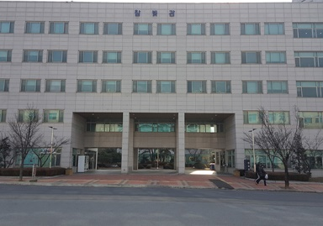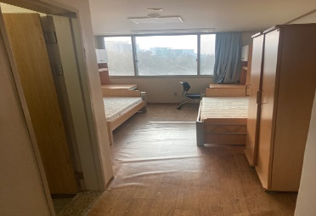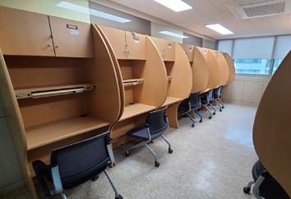
Estimated cost  (reference only) | Tuition fee: waived  Housing: KRW 740,000 (USD 520) per one semester (Aug. to Dec.)  Meals: KRW 5,000 (USD 4) per one meal (for on-campus dining)  Health Insurance: KRW 79,000 (USD 55) per one month  - Estimates do not include books, clothing, travel, entertainment,  holidays or miscellaneous expenditures.  - Fees are subject to change at any time.
Global  Buddy | A “Global Buddy” is a KOREATECH student, who acts as a mentor to an international student, to help facilitate integration into university life.  They help international students to become familiar with university courses, with the various locations and services the university provides and with city life and its cultural environment.
※ The above information may be changed depending on the circumstances.

- Main contacts
(General)
- WOOCHAN KIM (Mr.), Inbound & Outbound programs officer, Office of External Affairs
- E-mail: hahas507@koreatech.ac.kr
- Tel: +82 41 560 1795

(China)
- Xuejun Zhang(Mr.), Inbound & Outbound programs officer, Office of External Affairs
- E-mail: zxj100@koreatech.ac.kr
- Tel: +82 41 560 2502
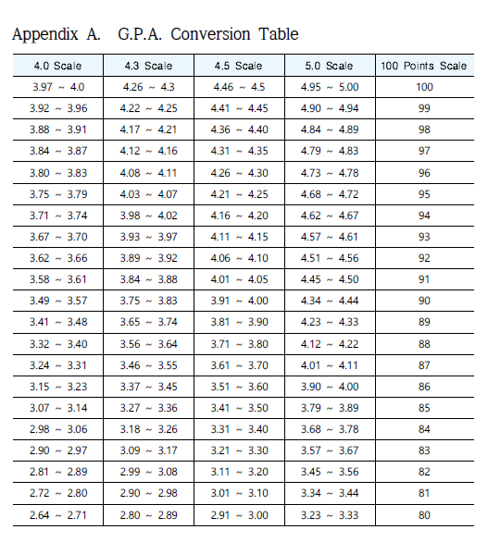
Application for KOREATECH Exchange Program

- Information of the Applicant
Full Name | *Please write your full name as indicated on your passport or official documents | Photo  Size: 3cm x 4cm
Date of Birth | (YYYY-MM-DD)  e.g., 1990-03-27 | Photo  Size: 3cm x 4cm
Country of Citizenship | ※ Korean Citizenship ☐ Yes ☐ No | Photo  Size: 3cm x 4cm
Contact Information  *Must be applicant’s | Address
Contact Information  *Must be applicant’s | Phone (start with the country code)
Contact Information  *Must be applicant’s | E-mail

- Academic Background
Currently  Enrolled  University | University Name
Currently  Enrolled  University | Location (Country) |   e.g., city name(country name)
Currently  Enrolled  University | Major
Currently  Enrolled  University | Semester | (Currently enrolled semester/Total semester) e.g., 3rd/8 semesters
Applying  University(in Korea) | University Name
Applying  University(in Korea) | Major

- Previous Visits to Korea or Currently Residing in Korea (if any)
Period | Purpose of Stay | City of Region | Affiliated Organization (if any) | Visa Type
e.g., 2019.July~August | e.g., exchange student | e.g., Seoul | e.g., GKS University | e.g., D-4

- Previously Received Scholarship from Korean Government or Institutions (if any)
Period | Name of the Scholarship | Sponsor
 | e.g., GKS Non-degree program for foreign exchange students | e.g., NIIED

- Language Abilities(if any)
TOPIK Level | ☐1 ☐2 ☐3 ☐4 ☐5 ☐6 급 | English Proficiency Test Scores | ☐ TOEIC | e.g., 850
TOPIK Level | Test Held/Test Date | English Proficiency Test Scores | ☐ TOEFL
TOPIK Level | e.g., 78th, 2021-10-16 | English Proficiency Test Scores | ☐ IELTS
※ Only valid certificate will be acknowledged / No submission is required for students from countries where English is the primary language.
THE ANSWERS I HAVE GIVEN ABOVE ARE TRUE AND CORRECT TO THE BEST OF MY KNOWLEDGE. IF MY ANSWERS CONTAIN ANY KIND OF FALSEHOOD, I WILL TAKE ANY LEGAL RESPONSIBILITY.

Date (yyyy-mm-dd) Applicant’s Full Name Signature

